User Authentication

POST: <http://localhost:3000/api/auth/login>

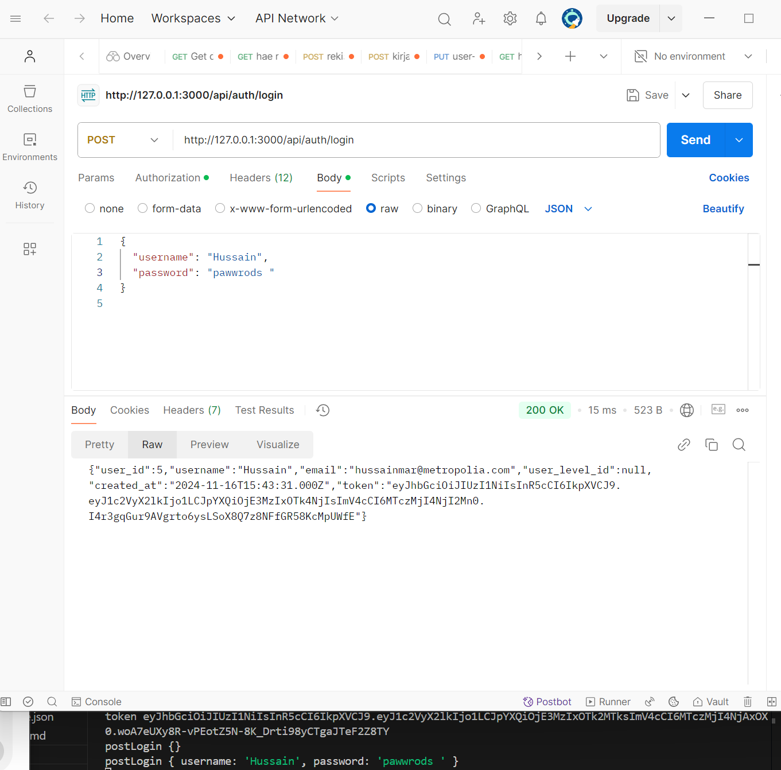

GET: <http://localhost:3000/api/auth/me>

GET: <http://localhost:3000/api/media>

POST: <http://localhost:3000/api/media>

PUT: <http://127.0.0.1:3000/api/media/11>

DELETE: <http://127.0.0.1:3000/api/media/11>

PUT: <http://127.0.0.1:3000/api/users>

